**BÀI ÔN TATC KHỐI 2 LẦN 5**

**TUẦN TỪ 30/3 ĐẾN 3/4/2020**

**ĐỀ 1**

**READING**

1. **Read and fill in the correct circle.**

|  |  |  |  |  |  |
| --- | --- | --- | --- | --- | --- |
| * 1. (A) apple   (B) fig  (C) orange | ⃝  ⃝  ⃝ | Moro” and “Sanguinello” Orange: from Sicily to Japan | Italian ... | 1. (A) teacher   (B) doctor  (C) nurse | ⃝  ⃝  ⃝ |  |
| 1. (A) pants   (B) shorts  (C) socks | ⃝  ⃝  ⃝ |  | * 1. (A) banana   (B) jelly  (C) tomato | ⃝  ⃝  ⃝ |  |
| * 1. (A) train   (B) car  (C) van | ⃝  ⃝  ⃝ |  |

1. **Read. Circle the correct answer.**

My Favorite …

What’s my favorite toy,

My favorite one of all?

Is it my car? Is it my ball?

No, it’s my red train.

What’s my favorite color?

You may like it, too.

Is it yellow? Is it pink?

No, it’s the color purple.

Son, age 7

**What’s my favorite toy?**

1. It’s a train.
2. It’s a ball.
3. It’s a car.

**What’s color is my train?**

1. It’s yellow.
2. It’s red.
3. It’s pink.
4. **What’s my favorite color?**
5. It’s yellow.
6. It’s pink.
7. It’s purple.
8. **Read and number.** 
   * + 1. My brother can’t find his kite. __1__
       2. Is it on the slide? No, it isn’t. _____
       3. Let’s find it together! _____
       4. He’s very happy now. _____
       5. Is it in the pool? Yes, it is! _____

* **Read again and write words from the box.**

Hoa’s brother wants his (1) _________. Sister looks on the (2)________. They can’t find it. Dad looks in the (3) ________. There it is! (4) _______ are happy!

|  |
| --- |
| **pool kite slide they** |

**WRITING**

1. **Look and write the word.**

o g t a

|  |  |
| --- | --- |
| 1.     _ _ _  e p n i c l  2.  _ _ _ _ _ _  3.  _ _ _ _  k o b o  i k b e  4. _ _ _ _  5. _ _ _ _ _ _  r f a e m r  o g l a   * + - 1. _ _ _ _   m u r b l l e a  7._ _ _ _ _ _ _  e t a h c r e  8.  _ _ _ _ _ _ _ |  |

1. **Write the words in the correct box.**

|  |
| --- |
| **doctor mom firefighter slide tree grandma student**  **goal nurse brother seesaw cousin** |

|  |  |  |
| --- | --- | --- |
| **jobs** | **family** | **park** |
|  |  |  |

1. **Write the sentence with a question mark and a capital letter.**

what’s this ____________________________

where’s my pencil case _____________________________

who are they _____________________________

is it a red bag **_____________________________**

**ĐỀ 2 WRITING**

**I. Answer the questions.**

|  |  |
| --- | --- |
|  | 1. Where is the ball?   _______________________________ |
|  | 1. Is it a window?   _______________________________ |
|  | 1. What are these?   _______________________________ |
|  | 1. How many pencils are there?   _______________________________ |
|  | 1. Is she a doctor?   _______________________________ |
|  | 1. What’s this?   _______________________________ |
|  | 1. Where’s the doll?   _______________________________ |
|  | 1. How many fingers are there?   _______________________________ |

**II. Look at the pictures and read the questions. Write one-word answers.**

**There is one example.**

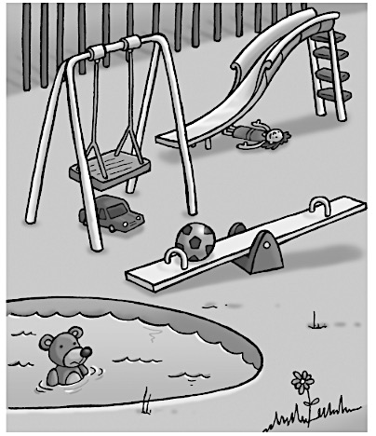

**Example:** How many teddy bears are there? ..…..one…….

1. Where is the doll? under the ……………
2. How many balls are there? ……………….
3. Where is the car? under the …….………
4. Where is the teddy bear? in the ………………...
5. How many cars are there? ……………….
6. How many dolls are there? ……………….